**Name – Chetan D. Chavan, ph.D.**

**Designation – Sr. Product Manager, IC/SP**

**Company Name – Thermofisher India Pvt. Ltd.**

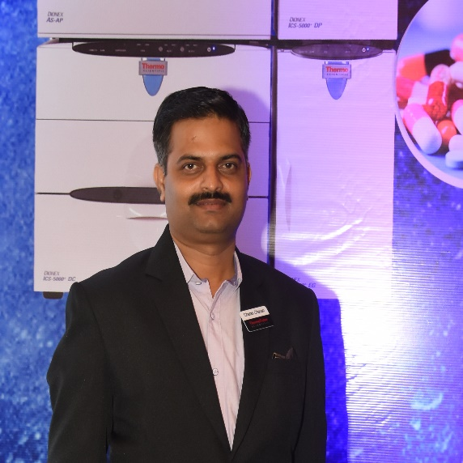

**My short CV -**

**Chetan D. Chavan** had done his graduation and post-graduation from Mumbai University and completed his Ph.D in year, 2018 using Ion Chromatography on the subject of estimation of drug impurities . He has joined Dionex India Pvt. Limited, which is now Thermo Fisher Scientific India Pvt. Ltd in 1997 as Application Manger for Ion Chromatography (IC) and HPLC. Presently working as Sr. Product Manager – IC/SP for India and SAARC countries with overall experience of 22 years in subject of Ion Chromatography and automated Sample preparation. He has published 9 research papers which comprises pharma, food, water and chemical industries.

**Name of the Topic –**

Capabilities and application of Ion Chromatography.